SAMPLE FILE

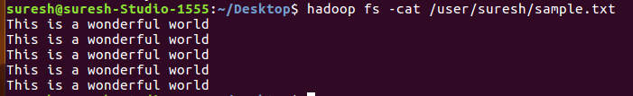

1. **Run a map only job on the word count program using static configurations**

**DRIVER CLASS:**

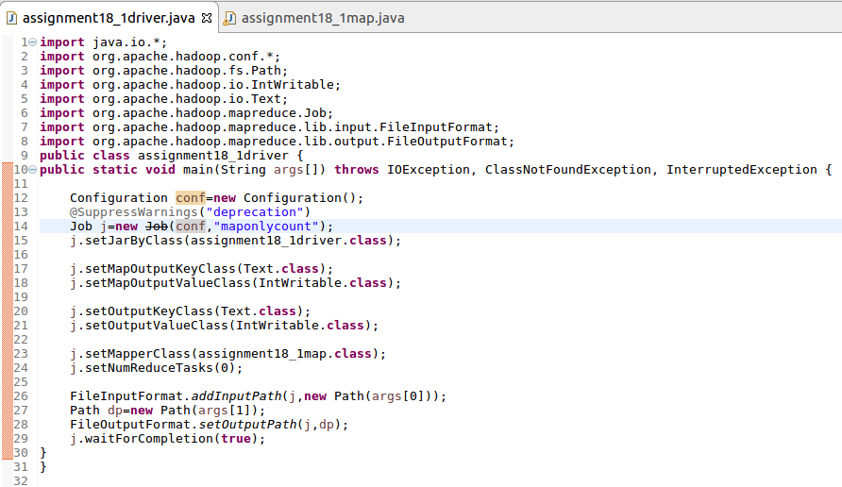

Setting the number of reducer tasks to 0 as there is no reducer.

**MAPPER CLASS:**

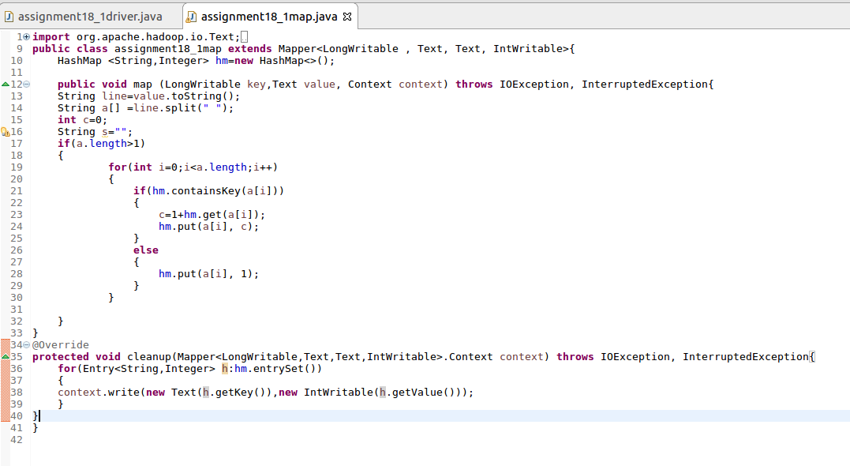

Making a count by extending mapper class and overriding cleanup method.

**RUNNING JAR :**

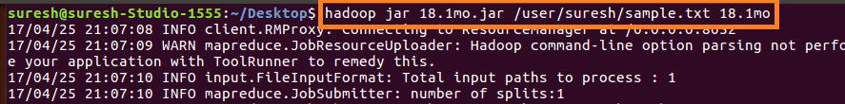

**OUTPUT**:

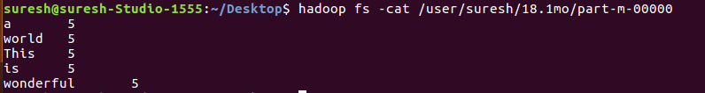

1. Run the mapreduce word count program and set the number of reducers to 2 using static configurations.

**DRIVER CLASS:**

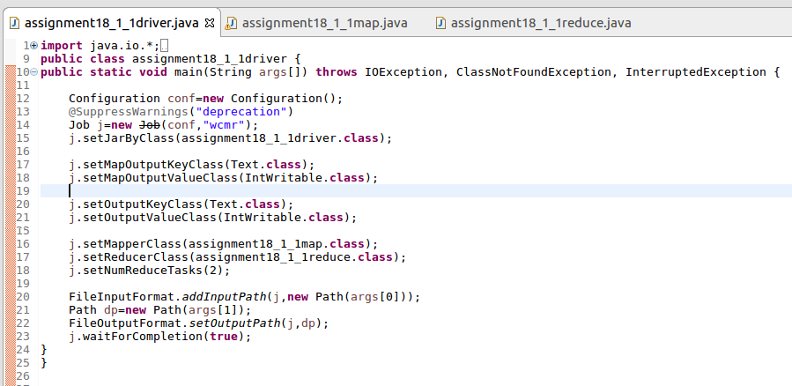

**MAPPER CLASS:**

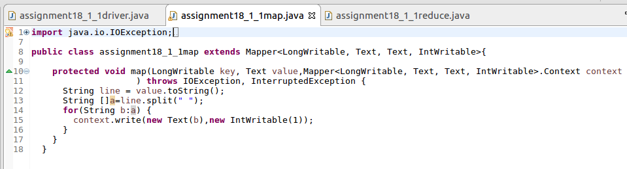

**REDUCER CLASS:**

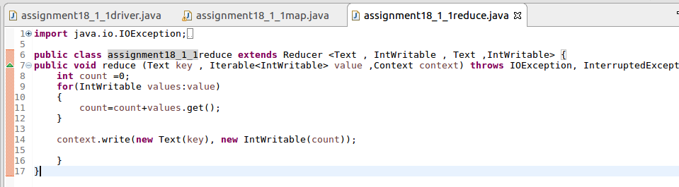

**RUNNING JAR:**



**OUTPUT**:

